Emporia Convention
&
Visitors Bureau

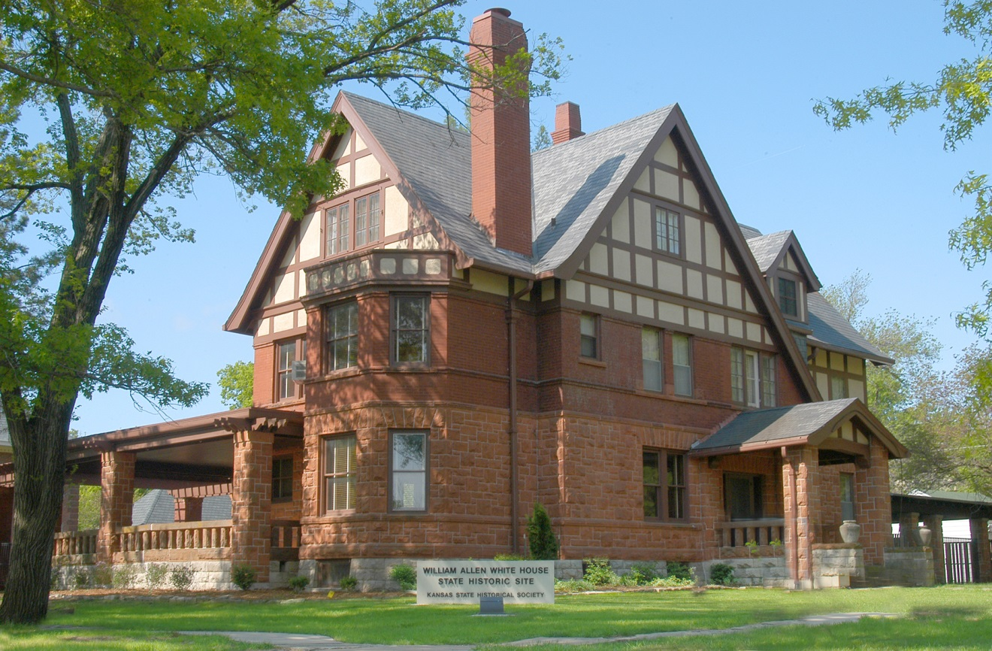
Strategic Plan
2014

What We Know:

Over the past year we have been building our organization for the 21st Century. Tourism in Emporia is being reshaped, and the CVB and Chamber staff, Advisory Board members, and stakeholders are committed to positioning Emporia as a destination.

In Kansas, tourism expenditures generated are $8 billion, and account for 32 million visitors. The average visitor spends $236 per trip. Travel and tourism provided $917 in tax relief to each Kansas household and state and local tax receipts equaled $32 per visitor. It was estimated in 2006 by Randall Travel Marketing, Inc. that Lyon County residents see a total tax relief per household of $154. This includes state, city, and county sales tax collections.

Through September 2013, the occupancy revenues in Emporia are up substantially over 2012. Several hoteliers report high numbers over 2012. Reports are still coming in from several individual hotels as there has been rapid turnover in many management positions. However, we believe the increase is primarily due to major sporting events and the Wolf Creek Outage, we must continue to retain, support, and help grow these events responsible for the increase.

The arrival of a new hotel this year will add 68 much-needed overnight rooms to Emporia’s lodging mix. We also know that we have many “tired” lodging properties in Emporia, some with ever-changing managers and management companies. Two properties will receive new identities but will hopefully continue to provide quality service.

Measuring the “tourism” industry is difficult. It is not measured in standard economic accounting systems. Tourism is a demand-side activity: the focus is on what the traveler buys before and during a trip. As a result, tourism touches many industries.

All Photos by imdesigngroup.com

Retreat 2013

On July 15, 2013, the CVB conducted a retreat for the Convention and Visitors Advisory Board, facilitated by Kansas Tourism Director, Becky Blake. All members attended including CVB staff, Jeanine McKenna, and city manager, Matt Zimmerman.

The retreat resulted in the establishment of six goals, each with strategies to accomplish the goals.

2013 Retreat Goals:

1. Conduct Market Research
2. Attract Leisure Visitors/Develop new website
3. Attract Meetings & Conventions
4. Communications
5. Develop Destination Assets
6. Attract Sporting Events

We took the retreat goals and compiled them into four main goals that encompass all the above. The number one goal is the market research. The research may affect the way we go about certain goals. The research will give us insight into Emporia’s niches and show us our strengths and weaknesses. The information provided is from previous research we have had or state wide information. The new website has been a top priority for some time as well. The website content will be affected by the research information. We plan to move forward with the new website as the information is being sought.

The following pages will explain our four priorities. All goals may be affected by the research results. The 2014 budget is also attached to show line items and how they match up with certain goals. These items are also subject to change depending on research results.

Emporia Convention & Visitors Bureau Mission Statement:

The Emporia Convention and Visitors Bureau is an investment tool for our community; enhancing economic development.

Emporia Convention & Visitors Bureau Vision:

The Emporia CVB strives to fulfill the expectations of the traveling public by providing quality, memorable experiences.

Convention & Visitors Advisory Committee:

Diane Trofholz, Chair
Arica Ahlvers
Roger Heineken
Robert Miller
Tracy Holroyd
Brandy Snyder-Nicholson
Melissa Windsor
Jose Feliciano, Chamber Liaison

Convention & Visitors Staff:

Interim CVB Director- Susan Rathke
Marketing Assistant- Christian Keisler

Conduct Market Research

The “old models” simply don’t work anymore. Everyone is competing for a piece of the pie; competition is fierce and growing stronger. The last market research completed for the Emporia CVB was in 2006 by Randall Travel Marketing, Inc. Marketing dollars are limited and we want to make sure we are spending them promoting our community in the most efficient way. We believe we need new research: a visitor profile; who is visiting Emporia, what are their demographics, what are they doing and how long are they staying. Also, a community assessment: what is the quality and condition of our lodging facilities, attractions, way-finding signage, etc. Completing this research will give us direction as we move forward and insights into what our trends are compared to the states, assets we have/don’t have. This research will be key in determining the way we move forward with marketing materials.

Goal 1: Complete marketing research in the forms of a visitor profile study and community analysis.

Objectives:

- Create RFP using CVAB retreat data
- Send RFP’s to research firms in Nov - due back in 30 days
- Choose firm and meet with firm to begin planning-launch research in January
- Receive results in 60 days-begin implementation
- Estimated cost $15,000-$30,000
- Request from the City Commission to encumber excess 2013 funds to finance this goal if needed

Points to keep in mind: All is subject to change when research is done

- Narrow our focus-find our niche & promote like crazy
- Tell why visitors should visit, why experience is different compared to other cities
- Promote experience over geography
- Use photos of people doing things
- Promote our “anchor tenants”
- Culinary Tourism is the fastest growing trend
- Biking is the 2nd fastest growing trend
- Gear marketing to the “real” decision makers-WOMEN
- Print marketing is the major driver to online inquiry
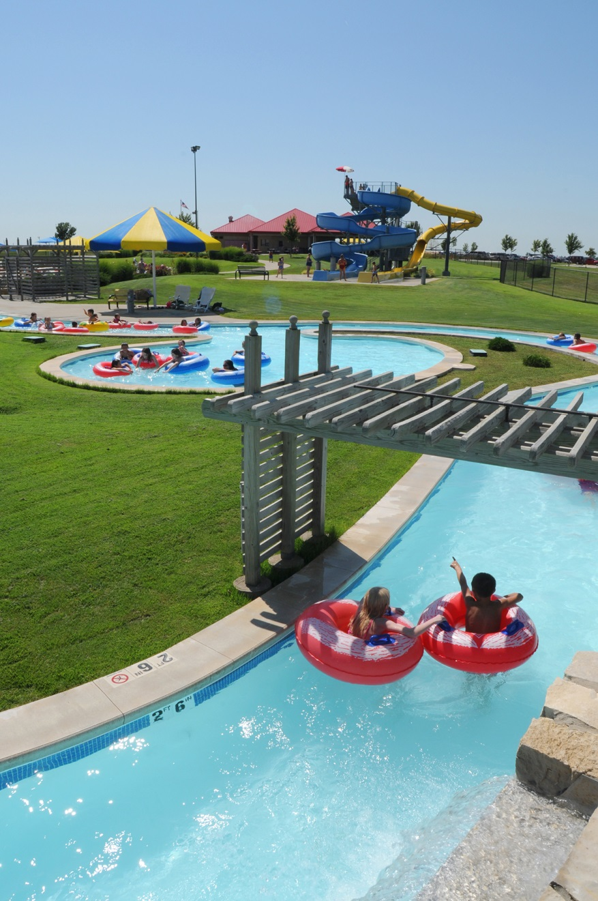

Develop a New Website

Our current website is out of date and lacks certain availabilities to be a magnet to draw outside people in. We have learned through conferences and studies that 45% of tourism is booked online and tourists seek information online. We need to create and maintain a new website to attract more visitors.

Goal 2: Develop a new website to enhance our online marketing using new features

Objectives:

1. Create RFP using CVAB retreat data
2. Send RFP’s to web development firms in November - due back in 30 days
3. Choose firm and meet with firm to begin planning
4. Launch new site in end of first quarter 2014
5. Estimated cost is $25,000-$40,000 based on firms given
6. Request City Commission to encumber excess 2013 funds to finance this goal-if needed

Points to keep in mind:

1. An improved website will lead to increased leisure, business, and meeting/convention planner travel
2. Web content must have strong appeal to women, as they make 80% of travel decisions
3. 94% of internet users decide where to travel, work & do business
4. 86% of internet users don’t go past 2nd page of a website- We plan to improve our SEO to get our name on first page at the top
5. 45% of our marketing dollars should be spent on the internet

Source: Roger Brooks International
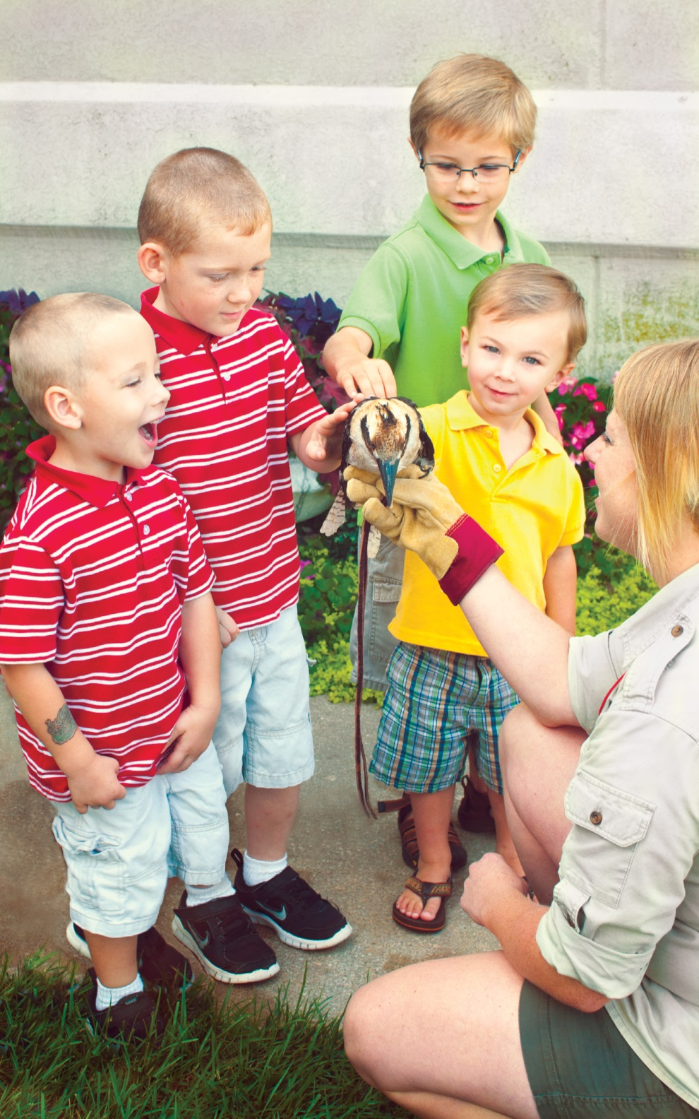
Communication
The city of Emporia strives to be a bigger and stronger community. We know that in order to grow, we need to form and strengthen existing relationships within the community. We need to connect with entities that have not taken advantage of our services. This will help us have better long-term communication to promote a positive community and be more progressive as we move forward with new goals in mind.

Goal 3: Strengthen relationships with community entities to combine efforts for event building, promotion and enhance communication.

Objectives:

1. Schedule regular meetings with tourism partners; such as hotels, attractions, ESU, Emporia Main Street, ERC
2. Schedule talks with civic and service clubs for meeting/convention business
3. Reach out to local professionals for meeting/convention business
4. Schedule meetings with local sporting event planners
5. Implement hospitality training with tourism partners
6. Promote CVB services to locals to develop “visiting friends & family” market through “Meet the CVB” events/promotions
7. Track meetings results and report monthly
8. Increase in meetings/conventions in 2014
9. Market future Hotel & Conference Center as a major destination

Points to keep in mind: Research will help us find out who our “key entities” are.

1. The most difficult “sell” in tourism is with local residents.
2. Consistency is key to maintaining relationships
3. We are in need of a stronger volunteer base to support community events
4. Much goes on to always know what is happening. Increased communication between entities will improve event monitoring and tracking.

Expectations: to increase overall communication and visitor traffic through above tactics.

Attract Meetings & Conventions

Our hotels are filled on weekends but we struggle to fill them during the week. One of our goals is to bring in Meetings & Conventions for week day purposes and fill those vacancies. A CVB member will do outside sales. Areas of interest are Topeka, Wichita, and Kansas City. Communication with Emporia hotels and convention centers will be vital to conduct outside sales. This will help us have a better understanding of venue capacity and amenities.

Goal 4: Have a staff person do outside sales to attract Meetings & Conventions to Emporia

Objectives:

- Delegate staff member to do outside sales
- Determine areas we lack in and days of the week
- Maintain monthly event calendar with convention sites
- Maintain monthly sales calls and meetings schedule
- Track results

Points to keep in mind:

- We are in need of more overnight business during the week nights in Emporia. This is an area we want to target.
- With a new convention center on the way and Emporia’s location, we have great opportunity for increased meetings and conventions
- Local businesses in need of convention sites Ex. (Glendo, Hostess, Wolf Creek, etc.)

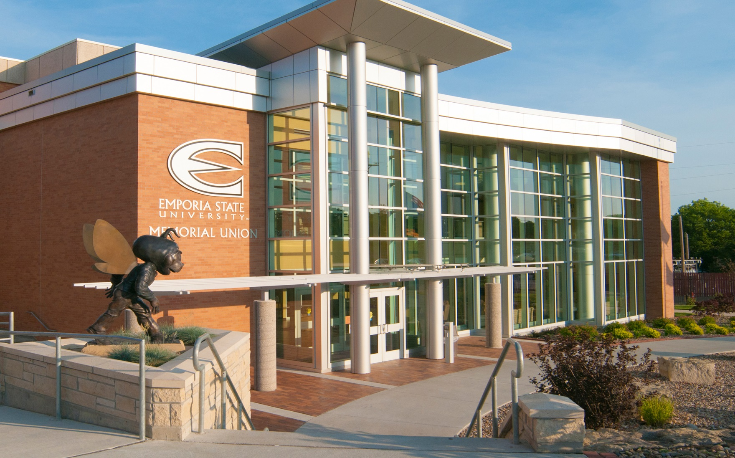
What does the CVB staff propose?

- Maintain CVB staff of 2 people
  - CVB Director & Administrative/Marketing Assistant

- Utilize volunteers and interns when needed & available
  - Visitor packet preparation
  - Lead generation mailings
  - Data entry
  - Social Media
  - Community Calendar

- Utilize findings from Research
  - For billboard advertising campaign
  - For target marketing efforts
  - For new website content direction

4. Utilize unused 2013 salary toward cost of research & website

5. Request Convention & Tourism funds from City Commission to
Finance research study and new website if needed

- Conduct outside local & outside sales for meetings/conventions market using current staff members- Notes: Time will determine if part time sales person is needed

- Utilize 2014 CVB Budget approved by City Commission- See goals attached to budget line items

- Investigate possible website ad sales-create new revenue source

“Monitor budget expenditures in 2014 to determine changes needed in accordance with research recommendations.”

